Michael Williams
10/5/2026
CS-305: Software Security
5-2 Coding Assignment:
Certificate Generation
Certificate Authorities (CAs) serve as the foundation of trust within a Public Key Infrastructure (PKI) by authenticating the identities of entities and binding them to cryptographic public keys via digital certificates. In modern web architectures relying on protocols such as Transport Layer Security (TLS) and Hypertext Transfer Protocol Secure (HTTPS), establishing secure communication requires more than mere encryption; it necessitates verifiable identity proof. Without a trusted mechanism to confirm a server’s authenticity, communication channels remain vulnerable to adversary attacks, including Man-in-the-Middle (MitM) exploits. When an entity employs a CA, the authority verifies domain ownership and organizational legitimacy before digitally signing the server's certificate. Web browsers and operating systems maintain pre-installed trust stores containing root CA certificates, enabling client applications to validate digital signatures automatically, authenticate remote servers, and negotiate encrypted sessions with complete cryptographic confidence (Rescorla, 2018).
Employing a trusted third-party CA provides several vital security and operational advantages over self-signed alternatives. The primary advantage is universal client trust, which prevents disruptive security warnings that undermine user confidence and encourage unsafe security bypass behaviors in production applications. Additionally, commercial CAs conduct standardized vetting procedures ranging from Domain Validation (DV) to Extended Validation (EV), ensuring that certificates are only issued to verified domain administrators and legally recognized entities. Beyond initial issuance, CAs oversee essential certificate lifecycle management, notably revocation services via Certificate Revocation Lists (CRLs) and the Online Certificate Status Protocol (OCSP). These mechanisms allow clients to verify immediately whether a compromised private key has been invalidated before its scheduled expiration date (Cooper et al., 2008). While self-signed certificates remain suitable for local development environments and internal testing, public production deployments depend on certified third-party authorities to preserve integrity, non-repudiation, and reliable authentication across the Internet.
screenshot of the certificate information form filled out with all fields completed
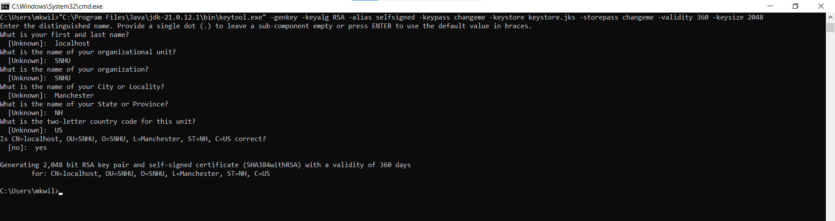
screenshot of the printout of the server.cer file
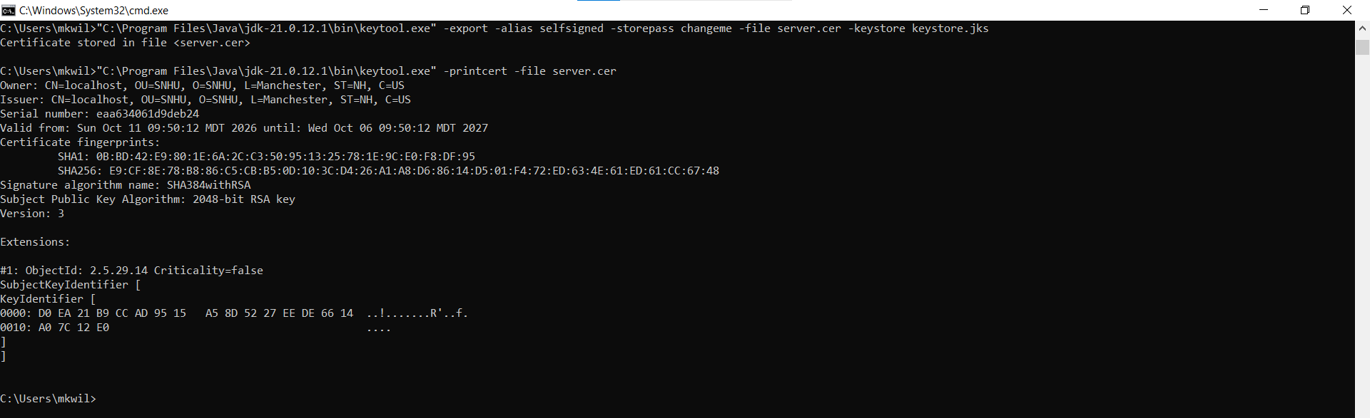

References
Cooper, D., Santesson, S., Farrell, S., Boeyen, S., Housley, R., & Polk, W. (2008). Internet X.509 Public Key Infrastructure Certificate and Certificate Revocation List (CRL) Profile (RFC No. 5280). RFC Editor. https://doi.org/10.17487/RFC5280
Oracle. (2021). keytool - Key and certificate management tool. Oracle Help Center. https://docs.oracle.com/en/java/javase/13/tools/keytool.html
Rescorla, E. (2018). The Transport Layer Security (TLS) Protocol Version 1.3 (RFC No. 8446). RFC Editor. https://doi.org/10.17487/RFC8446

